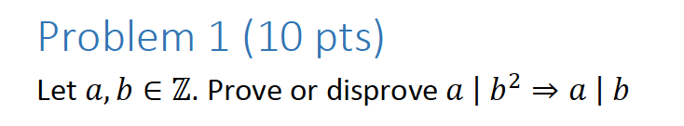

Counter Example:

a = 8, b = 4.

8 | 16 – Yes, this is true.

8 | 4 – This can’t possibly be true, because a number cannot evenly divide into a number smaller than it.



Since 12 | (7x + 3y), we know that 12 = m(7x+3y), for some integer m. Since 12 | (2z), we know that 12 = n(2z), for some integer n.

So, we can effectively split the equation we want to prove into two parts, then fill in 12c everywhere 7x+3y or 2z occurs.

-10x + 6y = (7x+3y) +(7x+3y) + 24x

= (12c) + (12c) + 24

12(c+c+24)

Thus, 12 | -10x + 6y.

-10z + 48 = -5(2z) + 48

= -5(12c) + 48

= 12(-5c + 4)

Thus, 12 | -10z + 48.

Finally, based on Theorem 4.1.1, and definition of divisibility if a | b and a | c, then a | b+c. So 12 | (-10x + 6y – 10z + 48)

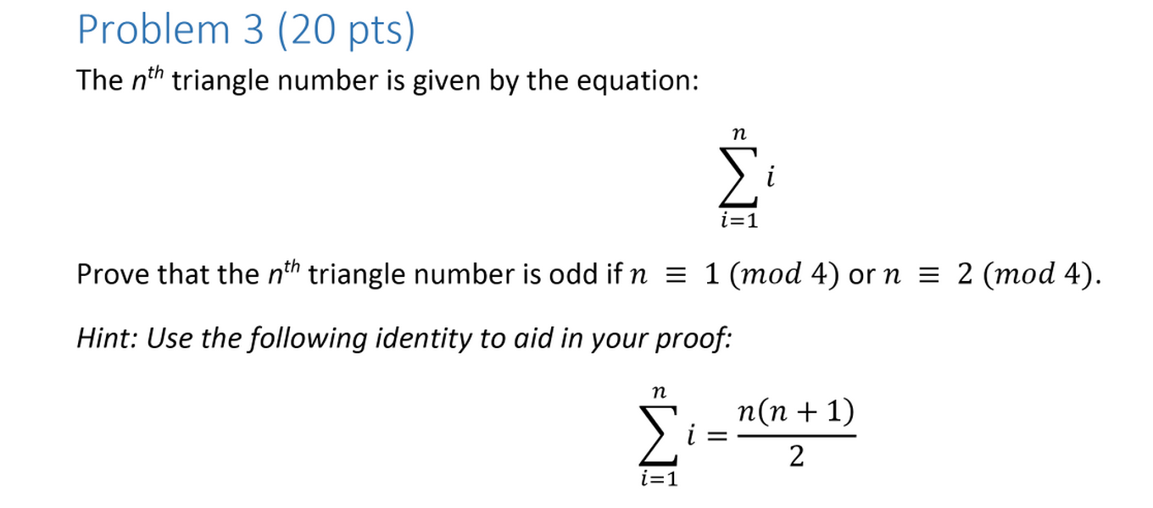

We know that since n is logically equivalent to 1, when modded by 4, we get the equation n = 4x+1. Likewise, n could also be equal to n = 4x + 2.

Now, let’s plug in n for both scenarios.

Left:

(4x+1)(4x+2) / 2

This is equal to 16x2+ 12x + 2 / 2 = 8x2+6x+1

Now let’s factor out a 2. 2(4x2+3x) + 1.

Since the entire equation can be created by multiplying by 2, but with an extra plus 1 at the end, the number must be odd.

Right:

(4x+2)(4x+3) /2 = (16x2 + 20x + 6) / 2

= 8x2+ 10x + 3 = 8x2 + 10x + 2 + 1

= 2(4x2+5x+1) + 1.

Since the entire equation can be created by multiplying by 2, but with an extra plus 1 at the end, the number must be odd, and the statement holds.

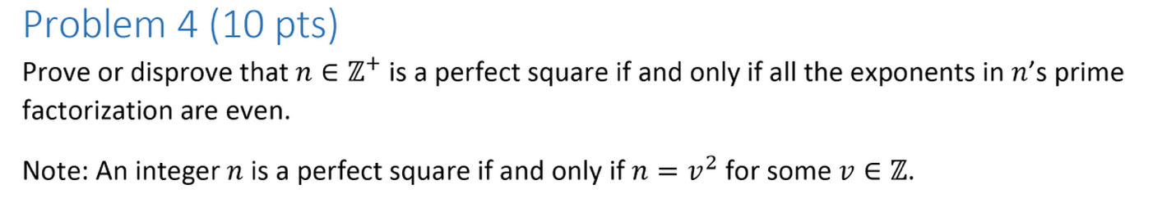

By the definition of a perfect square, n = v2.

We want to prove if all exponents in n’s prime factorization are even, then n is a perfect square.

If all of n’s exponents are even, n can be written such that n = x2k, of n= (xk)2.

**Since , the number can be expressed as a number squared, I know that if x is a perfect square, it’s exponents must be even, by definition of perfect square.**

We also want to prove that n is a perfect square if it’s exponents are all even.

Let us plug in both odd powers and even powers to see if this holds true.

n = v2k

n = (vk)2

**Thus, if the exponents are even, the number can be expressed as a number squared, and thus it must be a perfect square.**

Now for the odd numbers:

n = v2k+1

This can be expressed as n = (vk)2(v).

**This means that no matter what odd number we plug in, there will always be an extra variable hanging off of the end, so we cannot express n as a number squared, therefore all odd numbered powers cannot be perfect squares.**

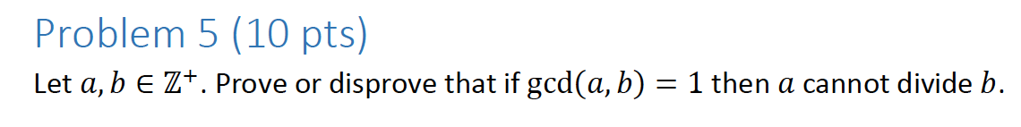

Let a = 1, and b = 1. Since gcd(1,1) = 1, and 1 divides into 1, this must be false.

B can actually be any number in this case, because 1 divides into any number. Thus, the above statement is false.

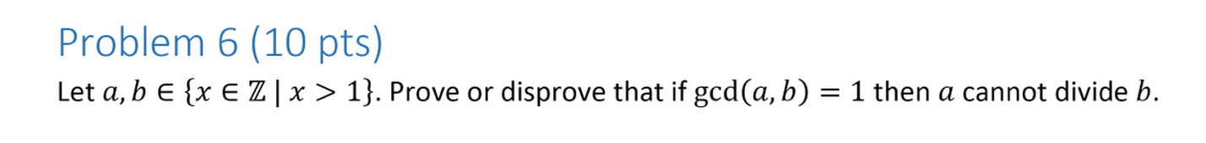

If the gcd of two numbers = 1, by definition, this means that the largest integer d such that d | a and d | b, is called the greatest common divisor of a and b is equal to 1. This means that a and b are relatively prime, and since neither value can be one, they cannot divide into each other.

Mathematically, according to Euclid’s algorithm, you can do the following:

Gcd(a,b) = b%a.

By definition of modulus division, if you divide out one number by another, then grab the remainder, the number you divided out cannot possibly be the remainder.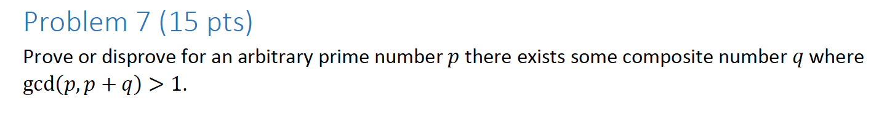

Since 1 is prime, let p = 1, let q = any composite number.

Well, the gcd(1, any composite number) = 1, since that is the only prime factor that both of them share. Thus, this statement must be false.



The set: {1,2,3,4,5,6,7,8,9,10}

Let’s prime factorize each composite number, and we shall leave the others since they are prime.

Prime factorized set: {1,2,3,22,5,3121, 7, 23, 32, 2151)

Thus, we need a minimum of 23 (32)5(7) = **2520**

I was able to do this because I know that the number must contain at least the factors in each of the sets, for 1, it has at least one 1, for 4, it has at least 22, etc etc.

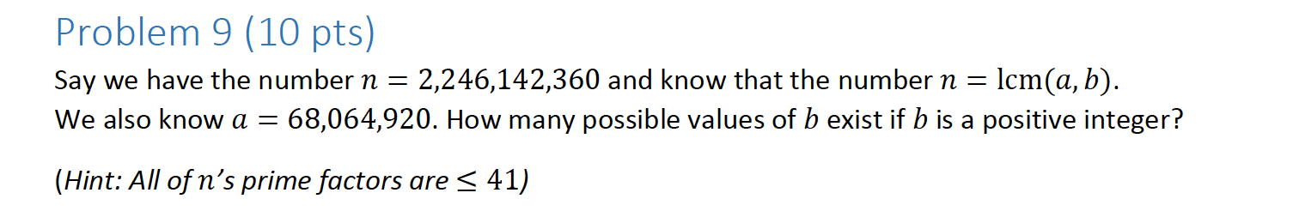

9.

n = 2,246,142,360 = (2^3)(31)(51)(73)(113)(41)

a = 68,064,920 = (2^3)(5)(73)(112)(41)

To get LCM(a, b), pick the greater power of each. B is a max of (31)(113)

There are two powers for three (0 and 1) and 4 powers for 11 (0,1,2,3).

Thus, there are 2 * 4 possibilities = 8 possibilities.

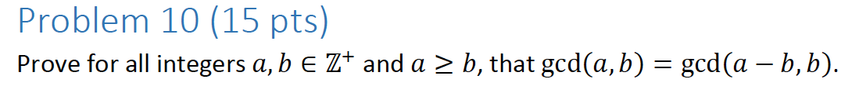

Bezout’s theorem states that ax+by=gcd(a,b).

Let’s plug this in.

I’m going to change the y to a z to make things simpler for the top equation.

gcd(a, b) = ax + bz

gcd(a-b, b) = (a-b)x + by.

This equals ax – bx + by

= ax + b (y-x)

Now, since we have our two equations:

gcd(a,b) = ax + bz, gcd(a-b, b) = ax + b(y-x).

Let’s divide the gcd’s on both sides.

1 = (ax+by) / gcd(a,b) 1 = ((a-b)x) + by) / gcd(a-b,b).

Now let’s substitute z = y-x. Since we know these are equal to 1, we can set them equal.

(ax+b(y-x) / gcd(a,b) = (a-b)x + by / gcd(a-b, b).

(ax-bx + by) / gcd(a,b) = ax-bx + by / gcd(a-b, b).

Thus, since both of the numerators are equal, the denominators must also be equal, and gcd(a,b) must equal gcd(a-b,b).

Q.E.D